**PACKAGES.**

**Scenario 1:** Group all customer-related procedures and functions into a package.

* + **Question:** Create a package **CustomerManagement** with procedures for adding a new customer, updating customer details, and a function to get customer balance.

**SOLUTION:**

**Query:** select * from customers;

**Output:**

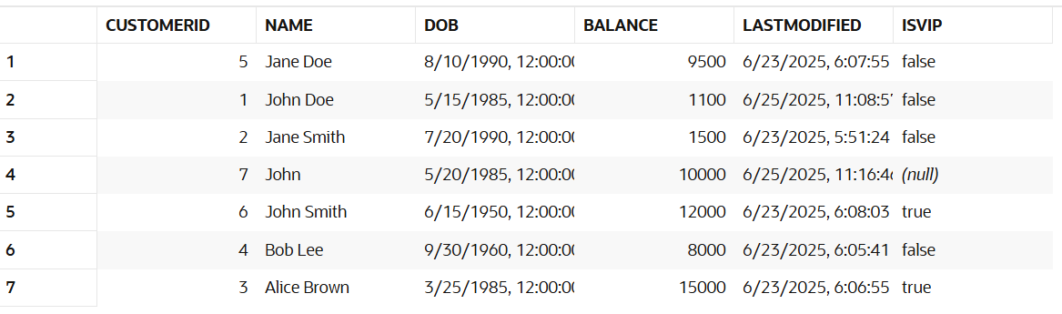

**Query:**

CREATE OR REPLACE PACKAGE CustomerManagement AS

    PROCEDURE AddCustomer(p_ID NUMBER, p_Name VARCHAR2, p_DOB DATE, p_Balance NUMBER,lstmodified date);

    PROCEDURE UpdateCustomer(p_ID NUMBER, p_Name VARCHAR2, p_DOB DATE, p_Balance NUMBER);

    FUNCTION GetCustomerBalance(p_ID NUMBER) RETURN NUMBER;

END CustomerManagement;

**Output:**

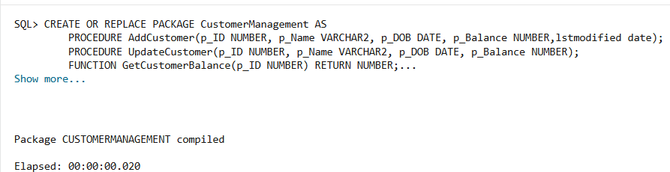

**Query:**

CREATE OR REPLACE PACKAGE BODY CustomerManagement AS

    PROCEDURE AddCustomer(p_ID NUMBER, p_Name VARCHAR2, p_DOB DATE, p_Balance NUMBER,lstmodified date) IS

    BEGIN

        INSERT INTO Customers (CustomerID, Name, DOB, Balance, LastModified)

        VALUES (p_ID, p_Name, p_DOB, p_Balance, lstmodified);

    END;

    PROCEDURE UpdateCustomer(p_ID NUMBER, p_Name VARCHAR2, p_DOB DATE, p_Balance NUMBER) IS

    BEGIN

        UPDATE Customers

        SET Name = p_Name,

            DOB = p_DOB,

            Balance = p_Balance,

            LastModified = SYSDATE

        WHERE CustomerID = p_ID;

    END;

    FUNCTION GetCustomerBalance(p_ID NUMBER) RETURN NUMBER IS

        v_balance NUMBER;

    BEGIN

        SELECT Balance INTO v_balance FROM Customers WHERE CustomerID = p_ID;

        RETURN v_balance;

    END;

END CustomerManagement;

**Output:**

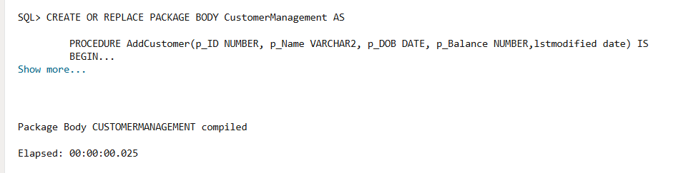

**Query:**

declare

c_bal number;

begin

    CustomerManagement.AddCustomer(8, 'Doe', TO_DATE('1985-07-15', 'YYYY-MM-DD'), 10000, SYSDATE);

    CustomerManagement.UpdateCustomer(1, 'John Doe', TO_DATE('1985-05-15', 'YYYY-MM-DD'), 5000);

    c_bal:=CustomerManagement.GetCustomerBalance(3);

    dbms_output.put_line('BALANCE OF CUSTOMER 3 IS: '||c_bal);

end;

**Output:**

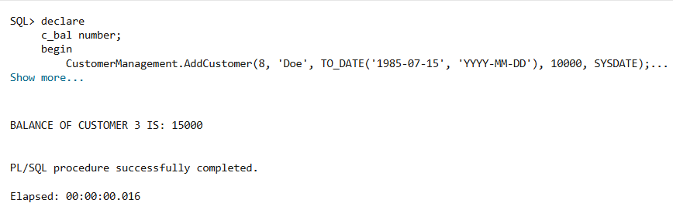

**Query:** select * from customers;

**Output:**

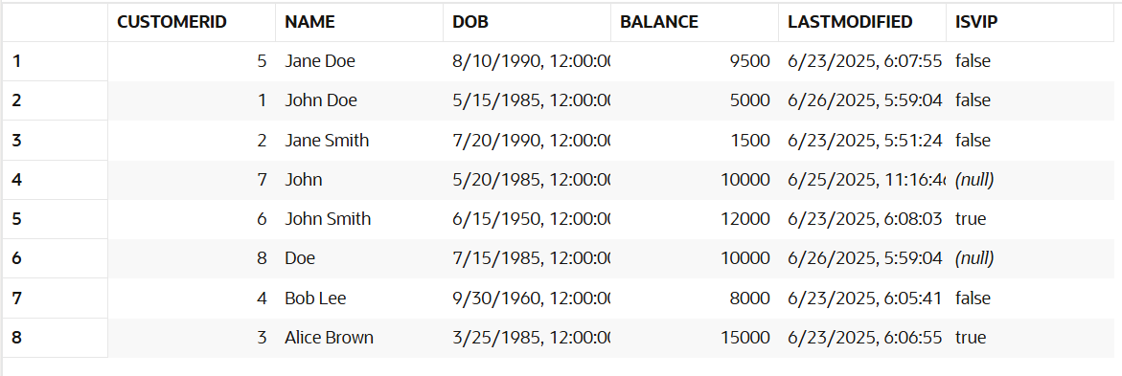

**Scenario 2:** Create a package to manage employee data.

* + **Question:** Write a package **EmployeeManagement** with procedures to hire new employees, update employee details, and a function to calculate annual salary.

**SOLUTION:**

**Query:** select * from employee;

**Output:**

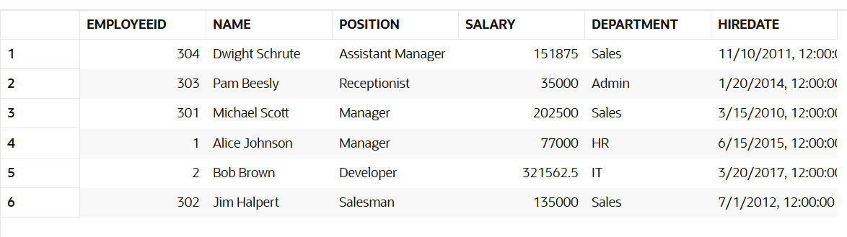

**Query:**

CREATE OR REPLACE PACKAGE EmployeeManagement AS

    PROCEDURE HireEmployee(p_ID NUMBER, p_Name VARCHAR2, p_Position VARCHAR2, p_Salary NUMBER, p_Dept VARCHAR2);

    PROCEDURE UpdateEmployee(p_ID NUMBER, p_Name VARCHAR2, p_Position VARCHAR2, p_Salary NUMBER, p_Dept VARCHAR2);

    FUNCTION CalculateAnnualSalary(p_ID NUMBER) RETURN NUMBER;

END EmployeeManagement;

**Output:**

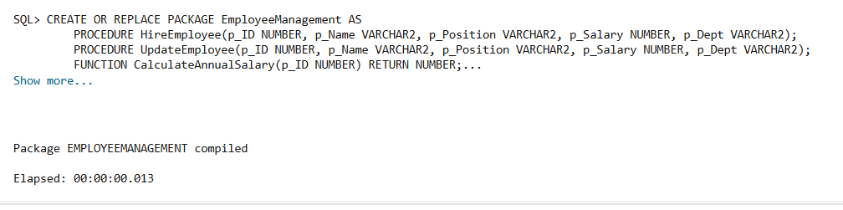

**Query:**

CREATE OR REPLACE PACKAGE BODY EmployeeManagement AS

    PROCEDURE HireEmployee(p_ID NUMBER, p_Name VARCHAR2, p_Position VARCHAR2, p_Salary NUMBER, p_Dept VARCHAR2) IS

    BEGIN

        INSERT INTO Employee (EmployeeID, Name, Position, Salary, Department, HireDate)

        VALUES (p_ID, p_Name, p_Position, p_Salary, p_Dept, SYSDATE);

    END;

    PROCEDURE UpdateEmployee(p_ID NUMBER, p_Name VARCHAR2, p_Position VARCHAR2, p_Salary NUMBER, p_Dept VARCHAR2) IS

    BEGIN

        UPDATE Employee

        SET Name = p_Name,

            Position = p_Position,

            Salary = p_Salary,

            Department = p_Dept

        WHERE EmployeeID = p_ID;

    END;

    FUNCTION CalculateAnnualSalary(p_ID NUMBER) RETURN NUMBER IS

        v_salary NUMBER;

    BEGIN

        SELECT Salary * 12 INTO v_salary FROM Employee WHERE EmployeeID = p_ID;

        RETURN v_salary;

    END;

END EmployeeManagement;

**Output:**

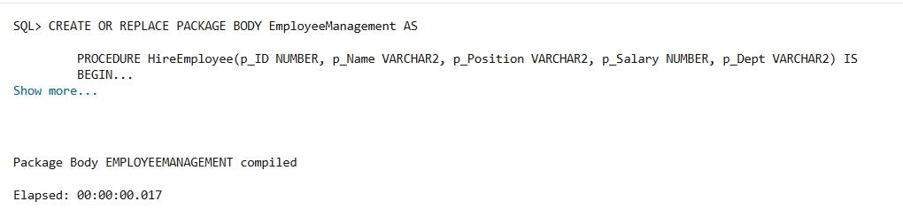

**Query:**

declare

annual_salary number;

begin

    EmployeeManagement.HireEmployee(3,'John','Manager',50000,'IT');

    EmployeeManagement.UpdateEmployee(301,'Michael Scott','Senior Manager',300000,'Sales');

    annual_salary:=EmployeeManagement.CalculateAnnualSalary(304);

    dbms_output.put_line('ANNUAL SALARY OF EMPLOYEE WITH ID 304: '||annual_salary);

end;

**Output:**

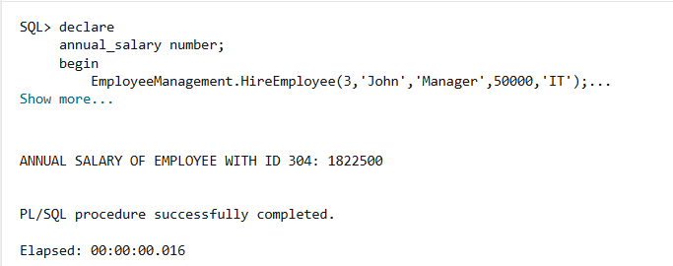

**Query:** select * from employee;

**Output:**

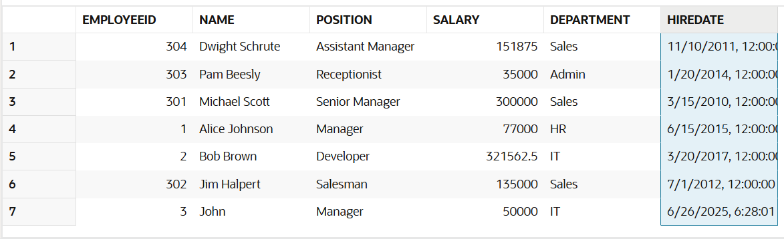

**Scenario 3:** Group all account-related operations into a package.

* + **Question:** Create a package **AccountOperations** with procedures for opening a new account, closing an account, and a function to get the total balance of a customer across all accounts.

**SOLUTION:**

**Query:** select * from accounts;

**Output:**

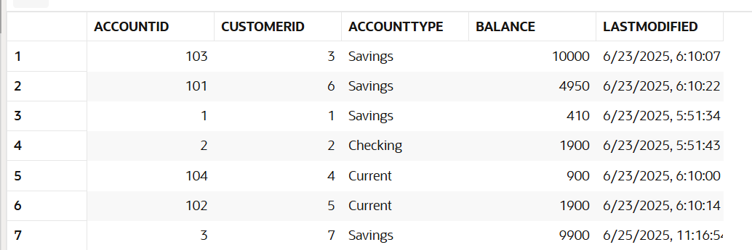

**Query:**

CREATE OR REPLACE PACKAGE AccountOperations AS

    PROCEDURE OpenAccount(p_AccID NUMBER, p_CustID NUMBER, p_Type VARCHAR2, p_Balance NUMBER);

    PROCEDURE CloseAccount(p_AccID NUMBER);

    FUNCTION GetTotalCustomerBalance(p_CustID NUMBER) RETURN NUMBER;

END AccountOperations;

**Output:**

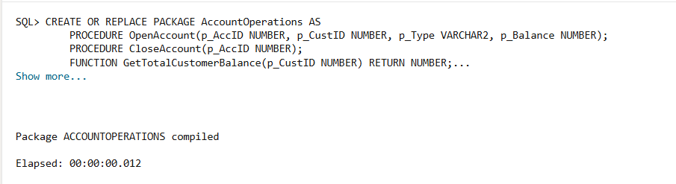

**Query:**

CREATE OR REPLACE PACKAGE BODY AccountOperations AS

    PROCEDURE OpenAccount(p_AccID NUMBER, p_CustID NUMBER, p_Type VARCHAR2, p_Balance NUMBER) IS

    BEGIN

        INSERT INTO Accounts (AccountID, CustomerID, AccountType, Balance, LastModified)

        VALUES (p_AccID, p_CustID, p_Type, p_Balance, SYSDATE);

    END;

    PROCEDURE CloseAccount(p_AccID NUMBER) IS

    BEGIN

        DELETE FROM Accounts WHERE AccountID = p_AccID;

    END;

    FUNCTION GetTotalCustomerBalance(p_CustID NUMBER) RETURN NUMBER IS

        v_total NUMBER := 0;

    BEGIN

        SELECT NVL(SUM(Balance), 0) INTO v_total FROM Accounts WHERE CustomerID = p_CustID;

        RETURN v_total;

    END;

END AccountOperations;

**Output:**

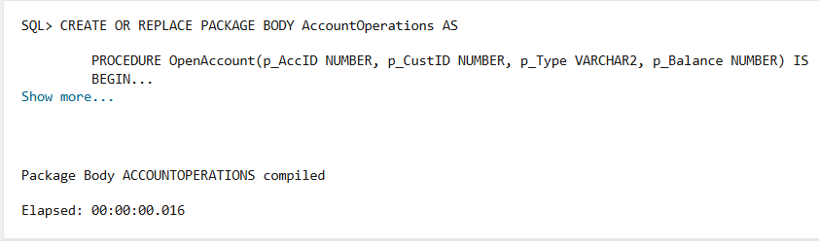

**Query:**

declare

c_balance number;

begin

    AccountOperations.OpenAccount(105,8,'checking',2500);

    AccountOperations.CloseAccount(105);

    c_balance:=AccountOperations.GetTotalCustomerBalance(3);

    dbms_output.put_line('BALANCE OF CUSTOMER 3 IS: '||c_balance);

end;

**Output:**

